**IMAGES**

About:

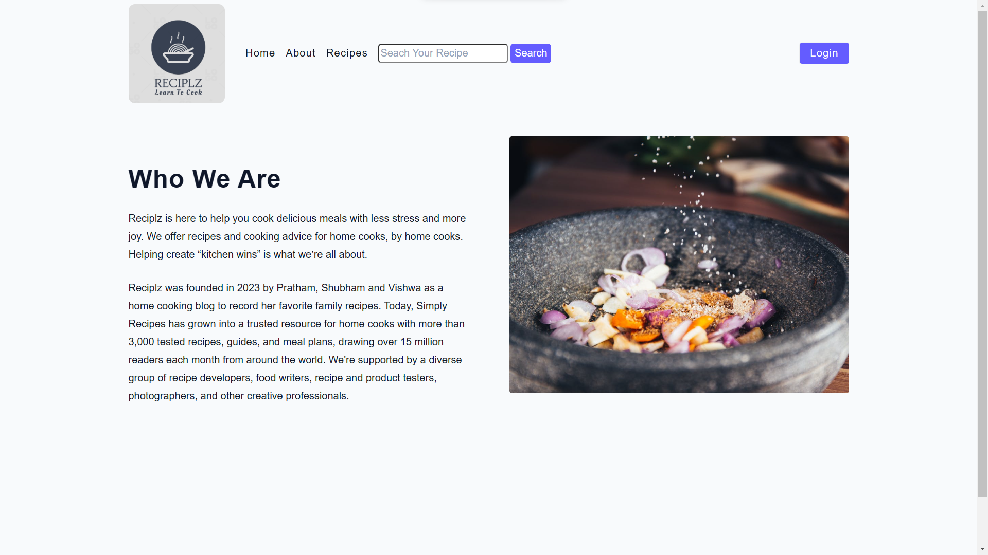

Home:

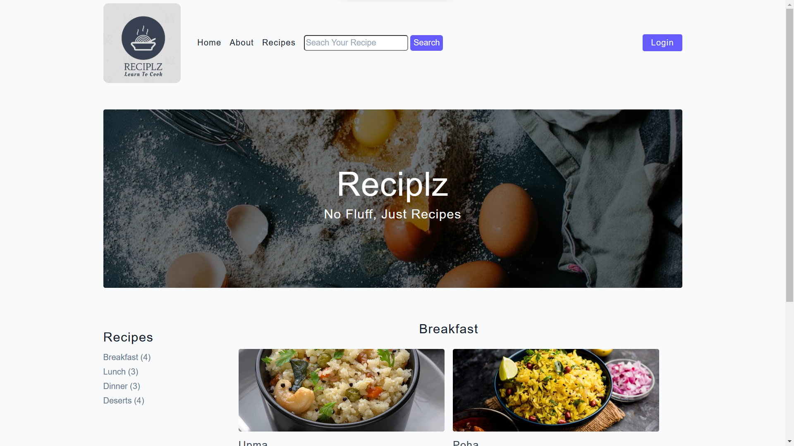

Login:

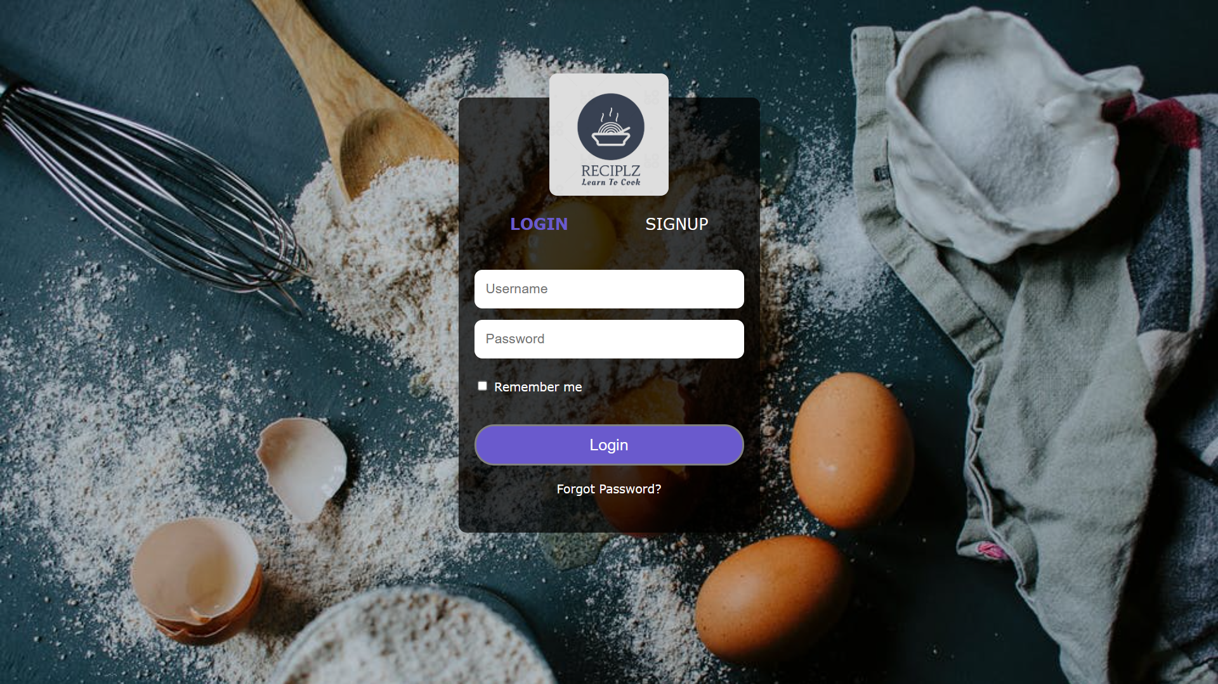

**CODE:**

INDEX

|  |
| --- |
| <!DOCTYPE html>  <html lang="en">  <head>    <meta charset="UTF-8" />    <meta http-equiv="X-UA-Compatible" content="IE=edge" />    <meta name="viewport" content="width=device-width, initial-scale=1.0" />    <title>Reciplz.com</title>    <!-- favicon -->    <link rel="shortcut icon" href="./assets/favicon.ico" type="image/x-icon" />    <!-- normalize -->    <link rel="stylesheet" href="./css/normalize.css" />    <!-- font-awesome -->    <link rel="stylesheet" href="./css/main.css" />  </head>  <body>    <!-- nav  -->    <nav class="navbar">      <div class="nav-center">        <div class="nav-header">          <a href="index.html" class="nav-logo">            <img src="./assets/logo.jpg" alt="Reciplz" />          </a>          <button class="nav-btn btn">            <i class="fas fa-align-justify"></i>          </button>        </div>        <div class="nav-links">          <a href="index.html" class="nav-link"> home </a>          <a href="about.html" class="nav-link"> about </a>          <a href="recipes.html" class="nav-link"> recipes </a>          <div class="nav-search">            <input type="text" placeholder="Seach Your Recipe"> <input type="button" value="Search">          </div>          <div class="nav-link Login-link">            <a href="Login.html" class="btn">Login</a>          </div>        </div>      </div>    </nav>    <br><br><br>    <!-- end of nav -->    <!-- main -->    <main class="page">      <!-- header -->      <header class="hero">        <div class="hero-container">          <div class="hero-text">            <h1>Reciplz</h1>            <h4>no fluff, just recipes</h4>          </div>        </div>      </header>      <!-- end of header -->      <section class="recipes-container">        <!-- tag container -->        <div class="tags-container">          <h4>recipes</h4>          <div class="tags-list">            <a href="Breakfast.html" target="cat">Breakfast (4)</a>            <a href="Lunch.html" target="cat">Lunch (3)</a>            <a href="Dinner.html" target="cat">Dinner (3)</a>            <a href="Deserts.html" target="cat">Deserts (4)</a>          </div>        </div>        <!-- end of tag container -->        <!-- recipes list -->        <div class="">          <iframe src="Breakfast.html" frameborder="0" name="cat" height="600px" width="100%" scrolling="no" frameborder="0">          </iframe>        </div>        <!-- end of recipes list -->      </section>    </main>    <!-- end of main -->    <!-- footer -->    <footer class="page-footer">      <p>        &copy; <span id="date"></span>        <span class="footer-logo">Reciplz</span> Built by        <a href="./about.html">Shubham, Pratham, Vishwa</a>      </p>    </footer>    <script src="./js/app.js"></script>  </body>  </html> |

About:

|  |
| --- |
| <!DOCTYPE html>  <html lang="en">  <head>    <meta charset="UTF-8" />    <meta http-equiv="X-UA-Compatible" content="IE=edge" />    <meta name="viewport" content="width=device-width, initial-scale=1.0" />    <title>About</title>    <!-- favicon -->    <link rel="shortcut icon" href="./assets/favicon.ico" type="image/x-icon" />    <!-- normalize -->    <link rel="stylesheet" href="./css/normalize.css" />    <!-- main css -->    <link rel="stylesheet" href="./css/main.css" />  </head>  <body>    <!-- nav  -->    <nav class="navbar">      <div class="nav-center">        <div class="nav-header">          <a href="index.html" class="nav-logo">            <img src="./assets/logo.jpg" alt="Reciplz" />          </a>          <button class="nav-btn btn">            <i class="fas fa-align-justify"></i>          </button>        </div>        <div class="nav-links">          <a href="index.html" class="nav-link"> home </a>          <a href="about.html" class="nav-link"> about </a>          <a href="recipes.html" class="nav-link"> recipes </a>          <div class="nav-search">            <input type="text" placeholder="Seach Your Recipe"> <input type="button" value="Search">          </div>          <div class="nav-link Login-link">            <a href="Login.html" class="btn">Login</a>          </div>        </div>      </div>    </nav>    <!-- end of nav -->    <br><br><br>    <main class="page">      <section class="about-page">        <article>          <br><br><br>          <h2>Who We Are</h2>          <p>            Reciplz is here to help you cook delicious meals with less stress and more joy. We offer recipes and cooking            advice for home cooks, by home cooks. Helping create “kitchen wins” is what we’re all about.          <p>            Reciplz was founded in 2023 by Pratham, Shubham and Vishwa as a home cooking blog to record her favorite            family recipes. Today, Simply Recipes has grown into a trusted resource for home cooks with more than 3,000            tested recipes, guides, and meal plans, drawing over 15 million readers each month from around the world.            We're supported by a diverse group of recipe developers, food writers, recipe and product testers,            photographers, and other creative professionals. </p>          </p>        </article>        <!-- needs fixes -->        <img src="./assets/about.jpeg" alt="Person Pouring Salt in Bowl" class="img about-img" />      </section>    </main>    <!-- footer -->    <footer class="page-footer">      <p>        &copy; <span id="date"></span>        <span class="footer-logo">Reciplz</span> Built by        <a href="./about.html">Shubham, Pratham, Vishwa</a>      </p>    </footer>    <script src="./js/app.js"></script>  </body>  </html> |

DB Connectivity:

|  |
| --- |
| *var* express = require("express");  *var* app = express();  *var* path = require("path");  *var* mysql = require("mysql2");  *var* port = 3000;  *var* con = mysql.createConnection({    host: "localhost",    user: "root",    password: "password",    database: "user"  });  con.connect(*function* (*err*) {    if (*err*) throw *err*;    console.log("Connected!");  });  app.use(express.urlencoded({ extended: true }));  app.use(express.static(path.join(__dirname)));  app.use(express.json());  app.get("/", *function* (*req*, *res*) {  *res*.sendFile(path.join(__dirname, 'index.html'));  });  app.get("/Login", *function* (*req*, *res*) {  *res*.sendFile(path.join(__dirname, 'Login.html'));  });  app.get("/user", *function* (*req*, *res*) {    con.query(`SELECT * FROM user WHERE name LIKE '%${keyword}%'`, *function* (*err*, *result*, *fields*) {      if (*err*) throw *err*;      console.log(*result*);  *res*.render("Login.html", { user: *result* });    });  });  app.post("/Login.html", *function* (*req*, *res*) {  *var* keyword = *req*.body.searchkey;    console.log(keyword);    con.query(`SELECT * FROM user WHERE name LIKE '%${keyword}%'`, *function* (*err*, *result*, *fields*) {      if (*err*) throw *err*;      console.log(*result*);  *res*.render("Login.html", { user: *result* });    });  });  app.listen(port, *function* () {    console.log("Example app listening on port 3000!");    console.log("http://localhost:" + port);  }); |

Output:

|  |
| --- |
|  |

MYSQL:

|  |
| --- |
|  |